AWARD PRESS RELEASE

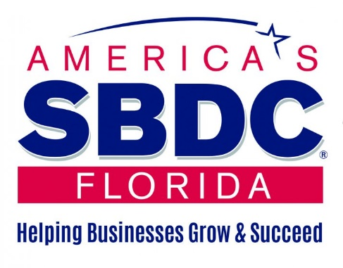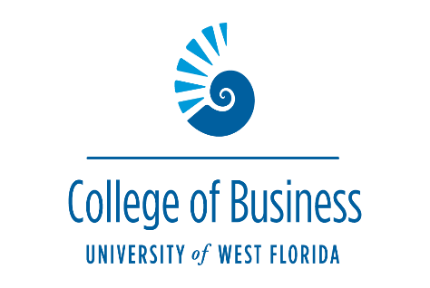
Contact Information:
Florida SBDC at UWF
Kevin Peterson
850-474-2552
kpeterson@uwf.edu

SBDC at UWF Takes Top Two Awards at State Conference

The Florida Small Business Development Center (SBDC) Network held their annual State Conference in Orlando last week, with representatives from all nine of the regional host partner universities and colleges in attendance. At the annual awards ceremony, the SBDC at UWF won Region of the Year after delivering more than 15,000 consulting hours to Florida businesses in 2018, topping centers at The University of Central Florida, Florida International University and the University of North Florida, among others. That work resulted in $554 million in sales increases, 5,072 jobs created or saved and over $31 million in capital infusion. The team also received recognition for their work in the weeks and months following Hurricane Michael, helping businesses between Apalachicola and Panama City Beach to Marianna and Chipley secure over $21 million in Emergency Bridge Loans, many of which were approved in less than a week. Regional Director Kelly Massey stated, “Although we do not need awards to know that the work we do matters, it is certainly nice to be recognized by your peers for your hard work. Our staff spent the better part of three months working away from homes and families to work in tents and buses, assisting with disaster recovery loans. We all worked long hours, including over the Thanksgiving, Christmas, and New Year’s holidays.” He adds, “Earning this award is more than a reward for hard work after the hurricane. Over the last five years we have come a long way and hired a lot of good people who are smart, don't mind hard work, and know how to help our clients succeed.”

Associate Director Adam McCloskey was also recognized as the Florida State Star for his leadership and performance. The award is the top honor any SBDC Consultant can receive. He was quick to share the credit though, stating, “Rarely has an individual award been such a group accomplishment. And I want to thank those teammates. I may have won the award, but if you trust our group to help your business grow & succeed, you're going to get great help, advice and tough love, no matter who you work with, because at the end of the day, you're working with us all as we collaborate and share.” In addition, McCloskey reached 115% of his consulting hours goal for 2018, accounted for $4.45 million in capital access for clients, launched the successful "Ask Adam" series in Navarre, and helped welcome a whole new staff to the Fort Walton Beach office due to retirement.

